**Willard City Newsletter - May 2022 Willard City CERT Prepper**

**Family Emergency TAKE ACTION Packet One in Every Household**

**The Great Utah Shake Out has come and gone. I hope that each Willard Area Citizen and Family, no matter where they were at, took the opportunity to practice “DROP, COVER and HOLD ON”. These are the actions needed to help protect yourself in the event of an earthquake. I hope, too, that each family took the opportunity to talk about “What If” this were a real earthquake……….**

**What happens next? What actions do you take? Are family members injured? How bad? Is it safe to stay in place? Do you need to evacuate? Do you have a 72 Hour Kit? Other supplies?**

**Does your Family have Disaster/Emergency PLANS????**

**In September 2006, as part of National Preparedness month, FEMA & Homeland Security introduced several Emergency Preparedness “AIDS” to help Families, Citizens and Communities better prepare for Emergency/Disaster situations. One of these “AIDS” was the Rapid Assessment Kit. The kit consists of an Instruction Sheet and 3 Colored pieces of paper. 1 Red, 1 Yellow and 1 Green. Following a disaster situation, family members rapidly assess their situation. Depending on what the situation is within their household, a corresponding colored piece of paper is posted in a front window or door that is easily visible from the street. As Emergency Response personnel pass through neighborhoods, they can rapidly assess the situation of each home by noting the color of the paper posted. This is a precious time saver for the Responders as they try to identify the most critical situations and injured people.**

**Additional information and instruction pages were also made available to further aid families striving to be prepared for all types of emergency/disaster situations.**

**In September of 2008, Willard City CERT introduced the “Family Emergency TAKE ACTION” packet to Willard City and surrounding community area residents. For years the packets were distributed by Block Captains to each household on their Block. The Captain would do a mini training session to inform and instruct on the use of the packet contents. That does not happen anymore.**

**But we still want every Family/Household to have a Take Action Packet. And we want them to understand and know how to use the contents of the packet. During the month of June, Willard CERT will hold an In Person and a ZOOM “Take Action” packet training Block Party.**

**Topics covered: 1) Rapid Assessment Kits, 2) Family Communication Planning, 3) Sheltering In Place, 4) Expedient Sheltering/Safe Room, 5) Community Evacuation, 6) Family Home Evacuation Plan, 7) Preparedness Kits, Supplies and Equipment.**

**Watch for these training Block Party dates and times posted on the Willard City Website, (**[**willardcity@comcast.net**](mailto:willardcity@comcast.net)**), Willard City CERT and Willard Resident Facebook pages.**

**Family Emergency “Take Action” packets are available for pick up at Willard City Hall.**

**Monday – Thursday 8 AM – 5 PM. Friday 8 AM – Noon Packets will also be available at the In-Person Class.**

**NO COST Pick One Up Today!!! For you and your Neighbor NO COST**

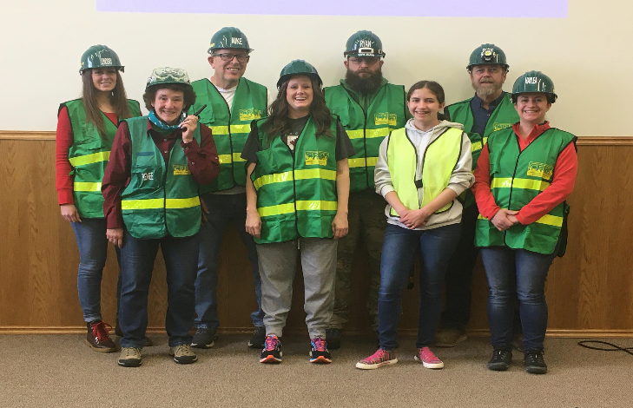

**CONGRATULATIONS TO GRADUATES OF THE**

**2022 SPRING CERT TRAINING CLASS !!!–**

**JORDAN HULSEY, ZACK HULSEY, NOVA**

**DUBOVIK, ALEX DUBOVIK, LINDSAY ROBISON,**

**KARI MOULTRIE, RICK LOOKEBILL, HAYLEA**

**WILSON, RYAN HEIDBRIER, MIKE BRAEGGER,**

**(5 ARE MISSING FROM THE PHOTO)**

**RENEE BEARD AND DIANE LOOKEBILL COMPLETED THE REFRESHER COURSE**

**TWO YOUTH – ADDIE AND AARON WILSON – ATTENDED THE COURSE**