June 2018 Newsletter
Willard City Corporation
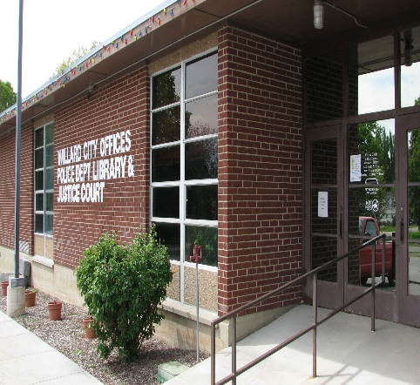Upcoming Events

June 7

Planning Commission – 6:30 p.m.

June 14
City Council – 6:00 p.m.

June 21
Planning Commission - 6:30 p.m.

June 28
City Council - 6:30 p.m.

The agendas for the meetings are posted at City Hall and on the State of Utah Public Meeting Notice website at www.utah.gov/pmn.

Important Announcements
ATTENTION MAIN STREET RESIDENTS – EAST SIDE – Some residents have had damage to their sewer laterals and natural gas lines during the installation of the fiber optic line along the east side of Main Street. If you notice the drains being slow suspect there may be damage please contact the City Office so we can contact the contractor.
UDOT- Hwy 89 and 750 North Stoplight Project :
UDOT has a project planned to install a stoplight and turning lanes at 750 North and Hwy 89 in 2018. They will also be resurfacing Hwy 89. Recent reports have indicated these projects may be put off until next spring. There have been some planning issues. We will update as we receive information.
We are fast approaching road construction season all over!!!! Please use caution around construction and SLOW DOWN and MOVE OVER for the safety of construction workers

80 W 50 S, PO Box 593 – Willard, UT 84340
435-734-9881 Website: www.willardcity.com
Summer Fun!

Cleaning out ???
If you are spring cleaning and have old sheets and blankets, why not donate them to our CERT program. Please make sure they are clean and bring them to the City Office. They will come in handy in an emergency!!!
4th of July – Together We Stand!!
The 4th of July Celebration will be here before we know it!!! VOLUNTEERS ARE STILL NEEDED!!! If you can spare a couple of hours on the 4th to help with one of the games, please contact Marjorie Ross (435) 730-0465. All the supplies for the games will be provided; we just need volunteers to help with the children games between 11am and 1pm. It would be so appreciated. Also, if you or someone you know would like to perform on the stage show in the park, please contact Terry Ross (435) 740-0889.

Join the Parade!!! Plan now to get your business or family together to be a part of the parade! Contact Tonya Huntsman at 801-808-1425. The theme this year is “Together We Stand”.

For a vendor booth, please sign up at the city offices during office hours. Cost will be $20 a booth.

The Patriotic program will be Monday, July 2 at 7 p.m.; contact Helen Jane Lemon at 435-723-5550 if you would like to participate in the program. Admission is free and there is some great talent lined up!

The Firefighter’s dinner/auction and dance will be Tuesday, July 3rd; contact any firefighter for dinner or raffle tickets. Dinner tickets are $8.50 for adults and $5.50 for children 12 and under. Tickets will be available at the door or from any Willard City Firefighter. Please support our GREAT Firefighters!! Don’t forget to buy lots of raffle tickets!!

On July 4th, there will be breakfast ($6.00 Adults, Seniors and Children 5-12 $5.00), the fun run, foot races, Bingo, games, the muzzleloader/archery shoot, baby contest, baseball games, a stage show and more. AND don’t forget the fireworks at the Willow Creek Park (Center & 200 E)! See the enclosed schedule for a list of events and times or visit the website www.willardcity.com for the schedule.

Streets and Water-
- Streets. Please clear debris from the sides of the roads to allow for summer maintenance along the sides the streets.
- Water – Protect our water system. Do you know putting a hose in a pool and then shutting it off without taking it out of the pool can contaminate drinking water? Planning on putting in a sprinkler system. Doing outside watering? Visit our website www.willardcity.com for valuable information on how to avoid cross connection and for important backflow prevention information. Help protect our water. Check out the Division of Water Resources website for great information on water conservation https://conservewater.utah.gov/
- Sewer- Property owners are responsible for the sewer clean out at or near the property line. Make sure sewer cleanouts are cut off at ground level and capped or protected to avoid debris from causing costly back-ups into your house and breaking off.
Police
- Dogs – There have been a number of dog bites already this year. The first questioned asked is when was their last rabies shot. Save yourself time and money and GET YOUR DOGS LICENSED!!!. All dogs over 6 months of age are required to be licensed. To license your dog we need proof of rabies vaccinations and proof of spay or neutering if they have been. Willard City allows 3 dogs maximum per residence. If you take them for a walk to the park or along the streets to “do their business”, clean up after them. Remember on the 3rd and 4th of July the Fire Department will be shooting off fireworks and there are often dogs that run off when this happens.
- Vehicle Burglaries- Vehicle burglaries are on the rise around town. One resident even found a screwdriver in the ignition of the vehicle! Keep your vehicles locked and valuables out of sight. Electronics, loose change, purses, wallets left in vehicles are what they are looking for. If you have a theft, see something suspicious, or a suspicious person, etc. call 911 WHEN IT HAPPENS or for non-emergency (ie. It is past occurred and no one is in danger) call 435-723-6890 WHEN YOU FIRST NOTICE IT!
- Scams –Door to door sales people are around during the summer. They must have a Willard City Solicitor’s license. Ask them and if they don’t call 435-734-3800 (Dispatch) for an officer to check on them. A business license only means they have met the City requirements for the license. Phone scams, mail fraud, and emails asking you to update banking or credit card information are rampant. Be award.
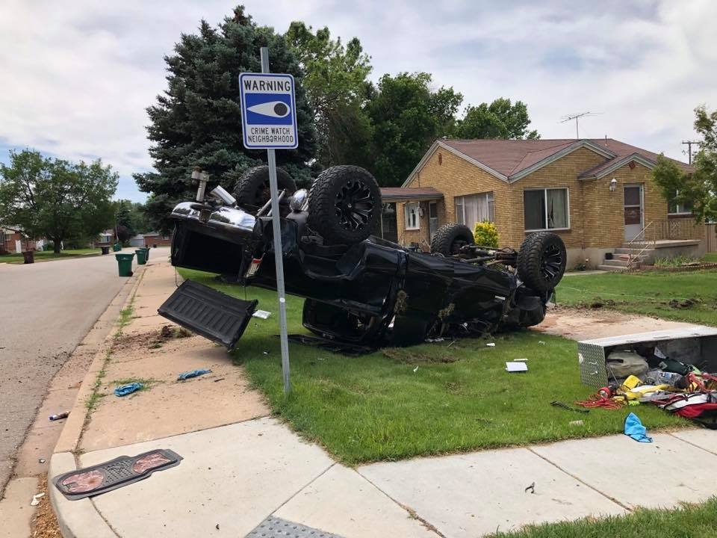
- Distracted driving – Put the cell phone down!!! The picture to the left is an accident that happened recently in a residential neighborhood by a driver distracted by a cell phone. School is Out – Be alert, especially in residential areas. Expect the unexpected. Children may cross the street at the wrong place or suddenly run or ride in front of you. Obey all laws. Slow down if there are children along the road or crossing the street. Come to a full stop at intersections. Be predictable. Don’t make sudden maneuvers that others, particularly children on foot or on a bicycle, are not expecting. Double check behind you and around you when backing out of a driveway or parking space. Again, don’t be distracted. Put down the coffee, put down the cell phone, and put both hands on the wheel. Avoid distractions within your vehicle, including loud music. Yield the right of way to pedestrians. It isn’t just courteous, it’s the law. Parents can help by reminding their children about staying safe on the roads. Also watch out for motorcycles!
- UTV/ATV Safety There has also been increase in ATV/UTV accidents and deaths already this summer. Here are some safety tips. Always wear safety equipment this includes helmets. In Utah, a helmet is mandatory for all riders (operators AND passengers) under the age of 18. Helmets must have at least a "DOT Approved" safety rating for motorized use...Always ride on a permitted roads. ...Do not drink and drive...Choose an ATV/UTV that's right for your age. Keep your arms and legs in the vehicle at all times and if equipped with seatbelts wear them...Oversee riders which are younger than 16 years. ...Ride on an approved trail. ...Take a hands-on ATV/UTV rider course.
- Speed limit 25 MPH – Unless posted otherwise the speed limit on City streets is 25 MPH. PLEASE SLOW DOWN. Areas where there have been a number of complaints of speeding drivers are 300 South and 200 W.
Have a fun, SAFE Summer!!!!!

